

**UNIVERSITI TEKNOLOGI MARA (UiTM)**

**CAWANGAN MELAKA KAMPUS JASIN**

**USER MANUAL: FOOD ORDERING SYSTEM**

**Group Members:**

|  |  |
| --- | --- |
| **Name** | **Matric No.** |
| Mohammad Afiq Bin Sabri | 2017358963 |
| Muhammad Arif Amzar Bin Ibrahim | 2017133157 |
| Farah Hazwani Binti Zulkifly Jamal | 2017944065 |
| Siti Aisyah Binti Azman | 2015664478 |

**Prepared By : PRIME**

**TABLE OF CONTENTS**

|  |  |
| --- | --- |
| **CONTENTS** | **PAGE** |
| Table of Contents | 2 |
| Introduction | 3 |
| Snapshots of the System: User Page | 4-6 |
| Snapshots of the System: Administrator Page | 7-10 |

**INTRODUCTION**

Arfa food booking system is a system that provide service of booking a place or restaurant based on the type of cuisine that are served in the specific restaurant. The user can easily locate the location of the nearest restaurant that they want to dine in as the system also provide a google API map.

This system are designed for the admin and the user.

This user manual provides a step-by-step operation needed to be done by the users of the system.

**USER PAGE**

1. Sign up page

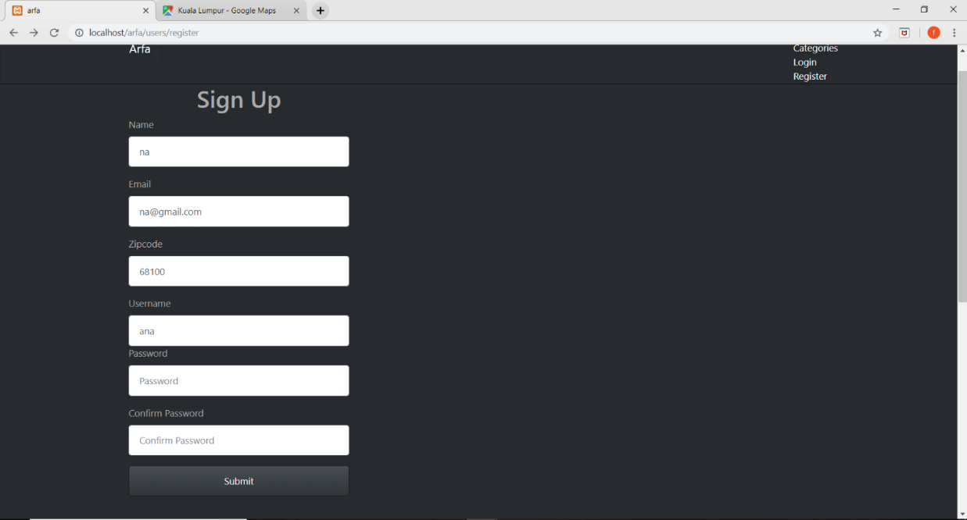

The user can sign up to access the system.

2. Home page

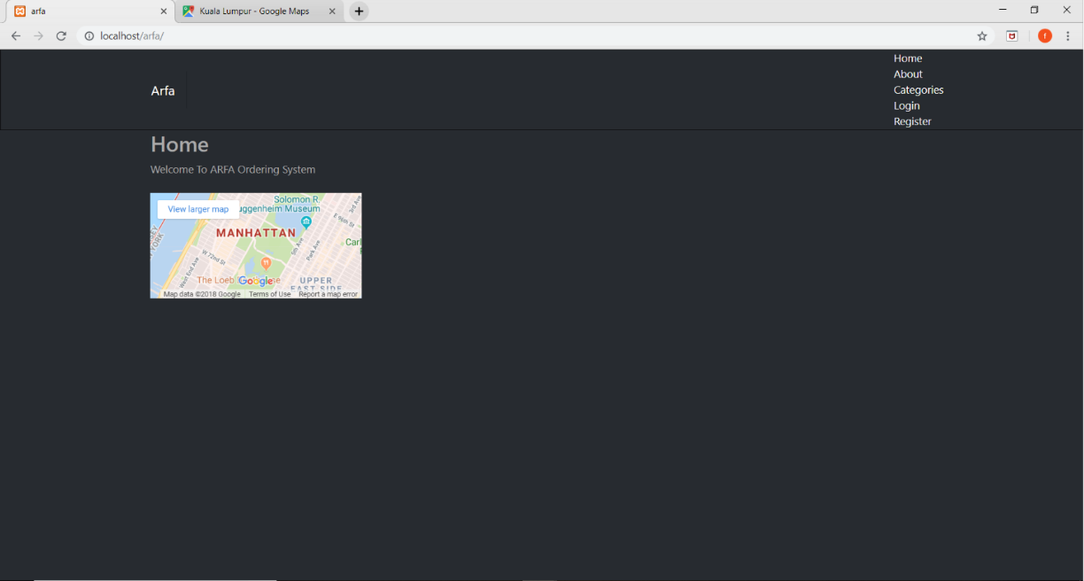

The system will provide a homepage that welcome the user. Google API map are provided to the user to locate the location of the restaurant that are booked.

3. About page

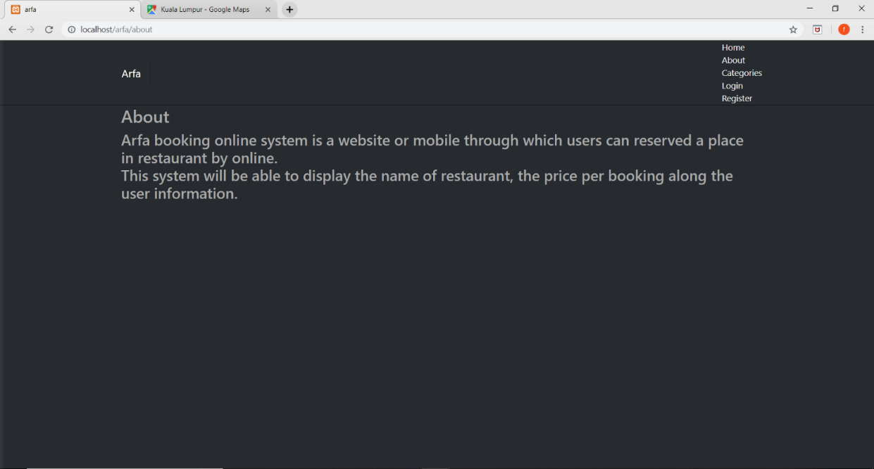

About page are used to inform the function and usage of the system.

4. Categories page

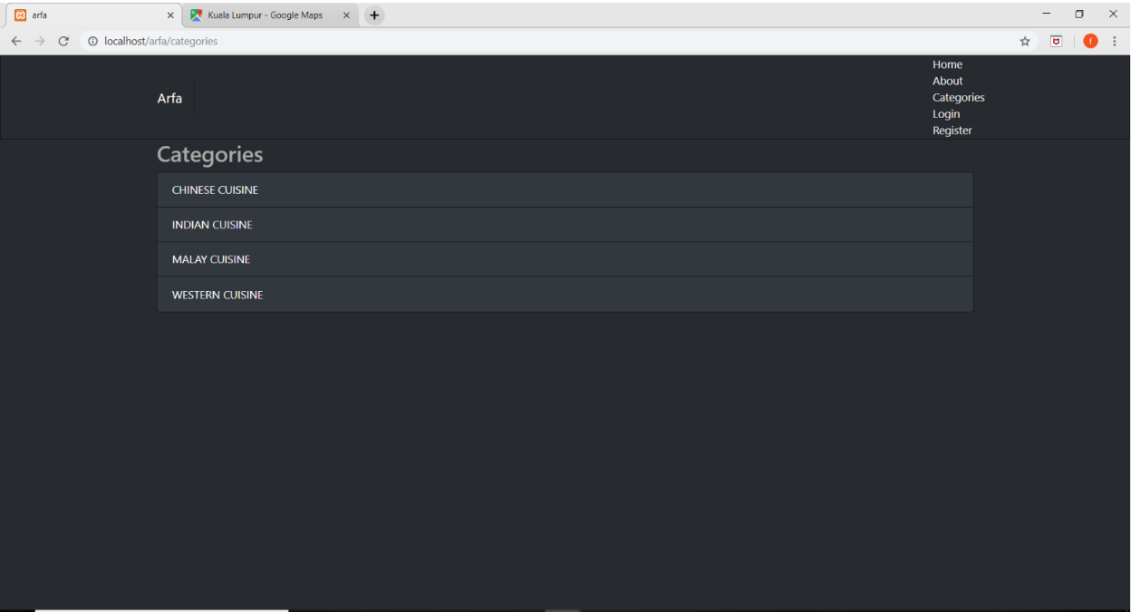

By clicking the menu button at the upper right of the page, user are able to view the categories page. The page will list out what kind of cuisine are available. The user must select a cuisine to view the restaurant list.

5. Post page

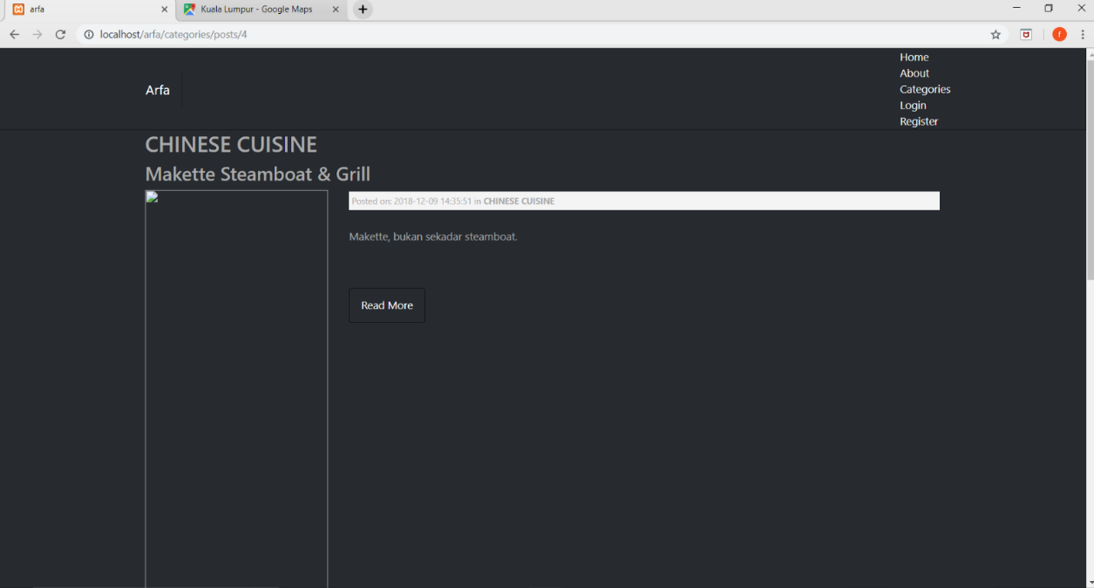

After user select the type of cuisine, a list of restaurant that serve the cuisine can be seen. User can click on the read more button to view the details.

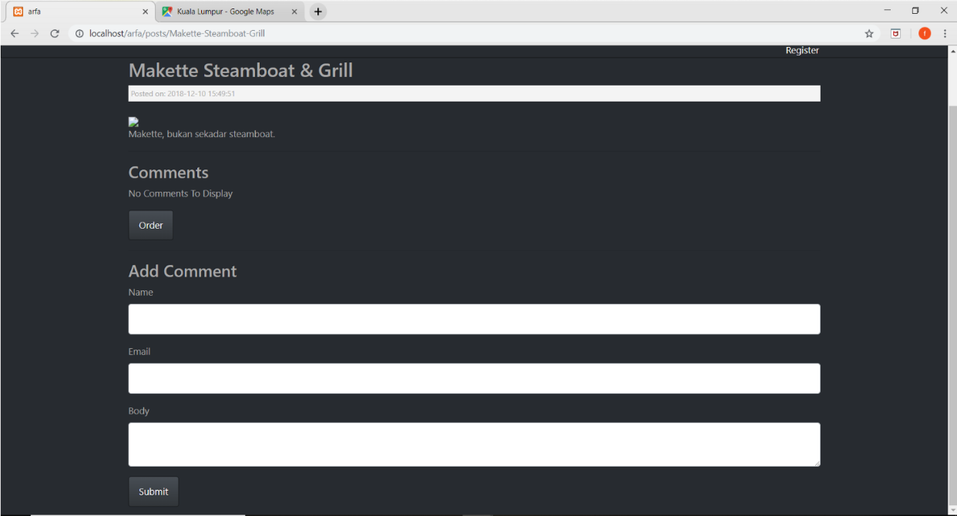

In this page the user are able to add comment by inserting the name, email address and the body comment. After clicking on the submit button, the comment will be added to the page.

**ADMINISTRATOR PAGE**

1. Sign in page

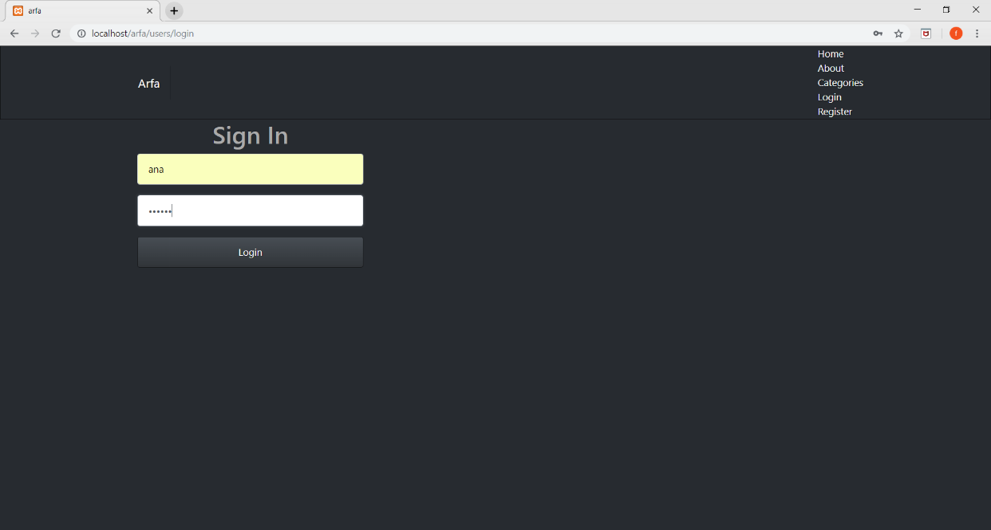

The admin can login the system by inserting his username and password.

2. Category page

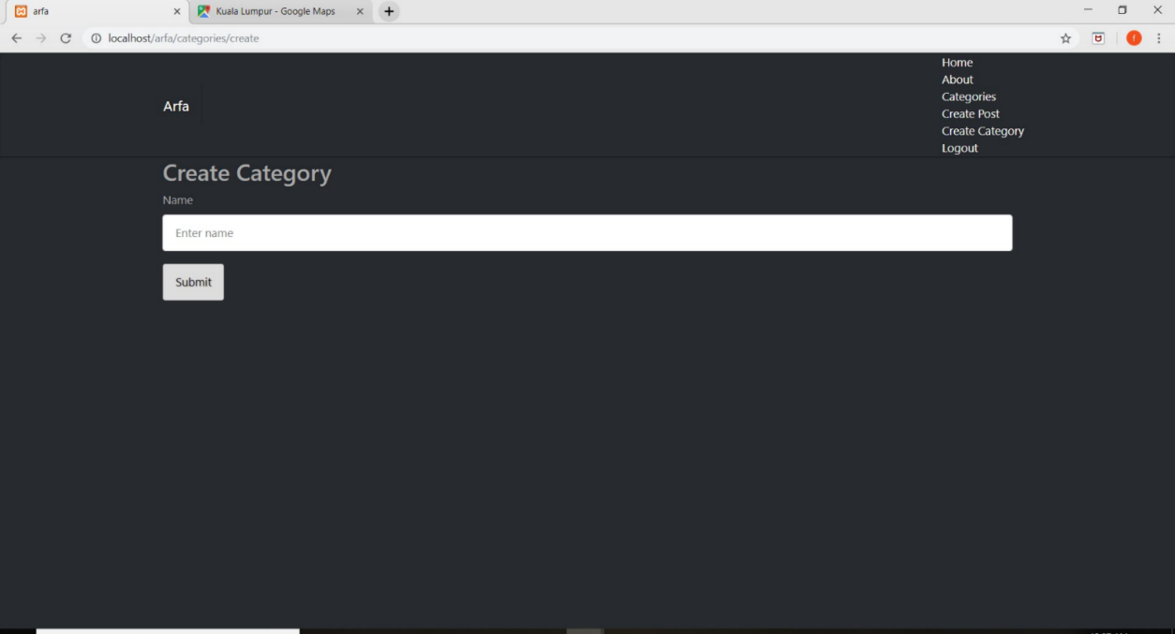

The category of cuisine type can be created here.

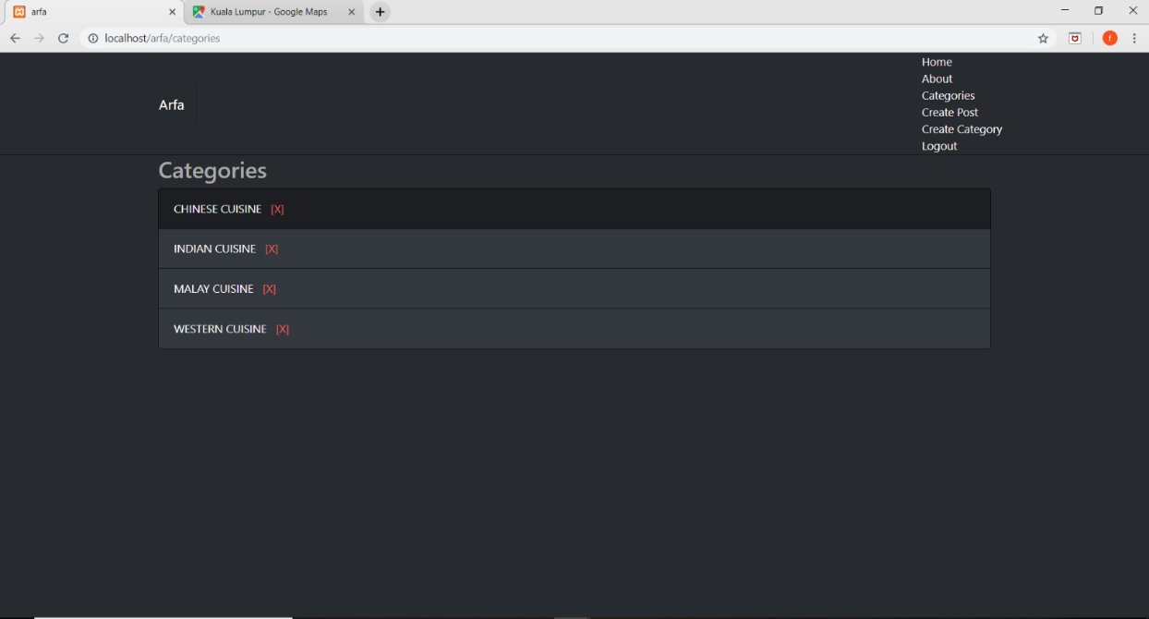

Admin can edit the categories by deleting the type of cuisine.

3. Post page

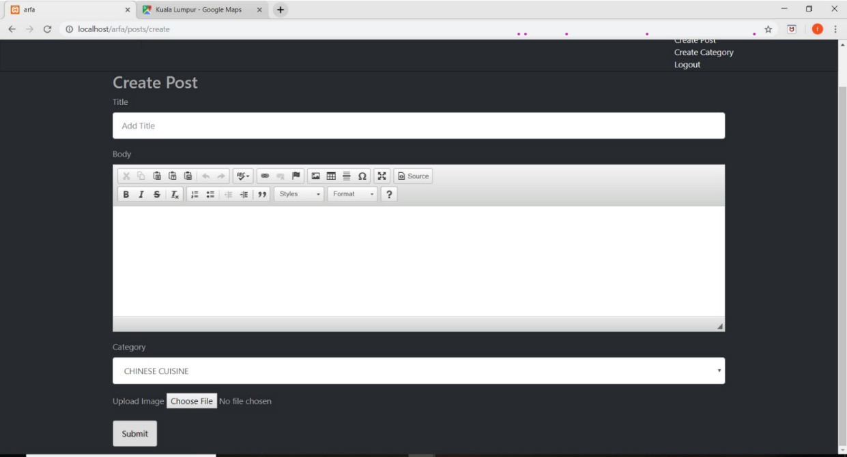

Admin can add or create the list of restaurant name that serve certain type of cuisine by fill in the title which is the restaurant name, the details of the restaurant in the body. The type of cuisine can be choose using a dropdown button.

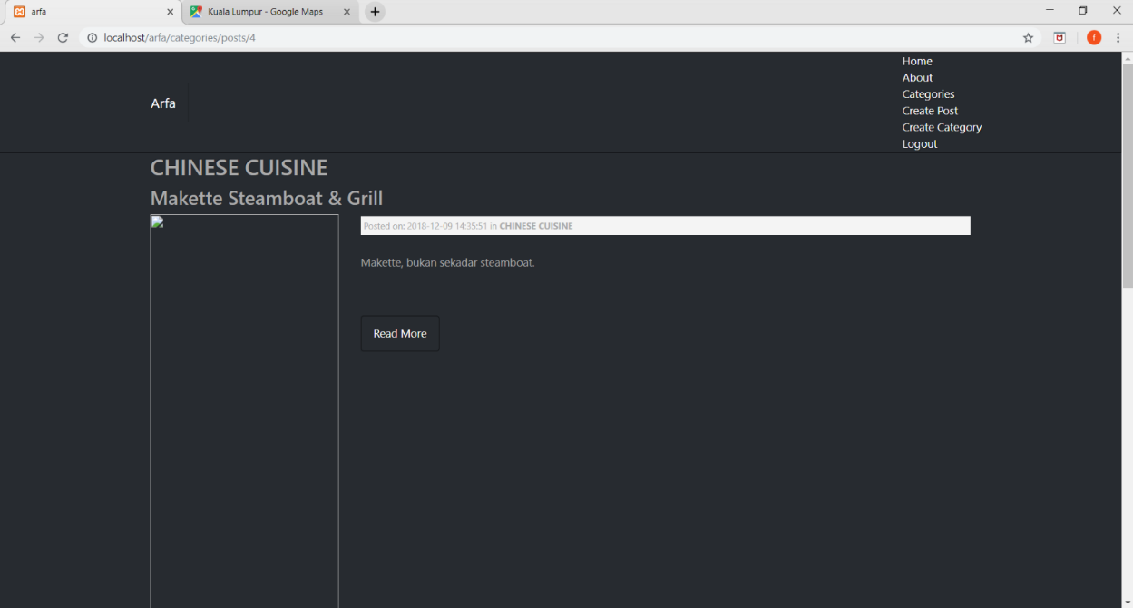

Then, the list of restaurant are displayed.

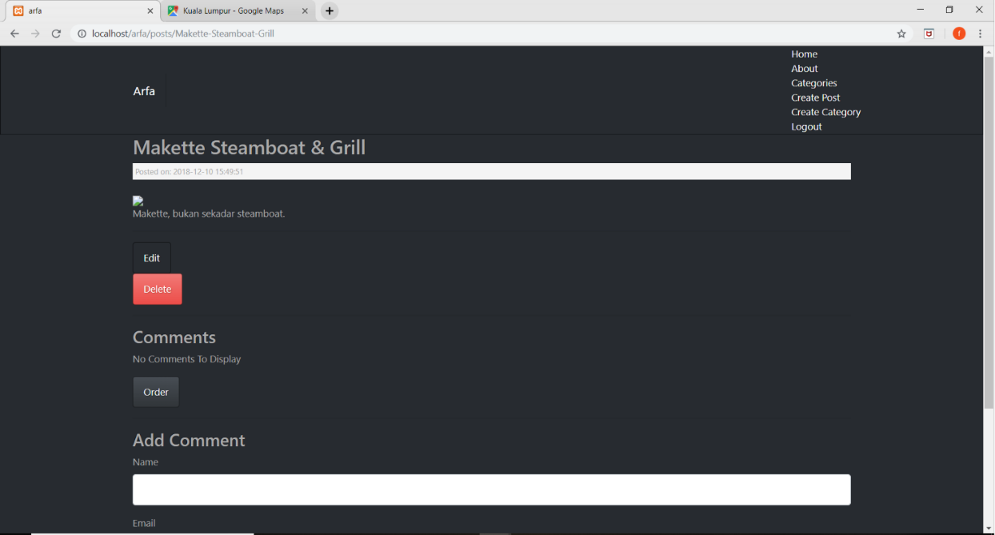

Admin can choose whether to edit or delete the information. Admin also can add comment for the restaurant.

4. User details page

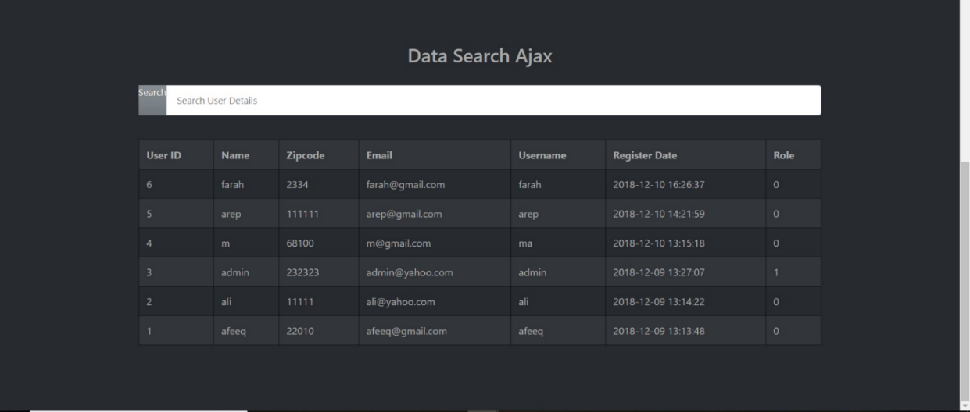

By using ajax, admin can view the information of the user.

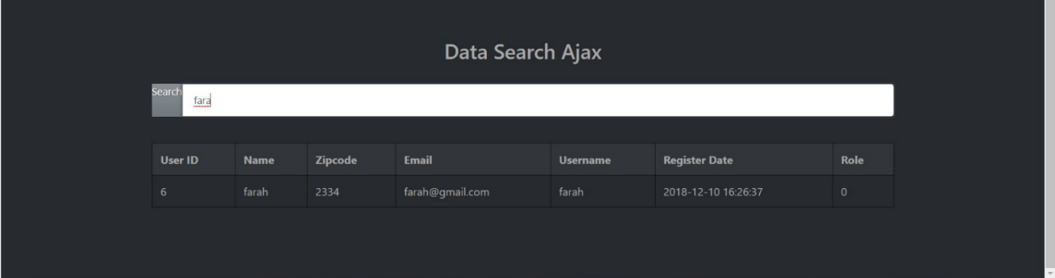

When the admin insert in details, the information for specific user will display.